**Gloomy gully assembly guide:**

*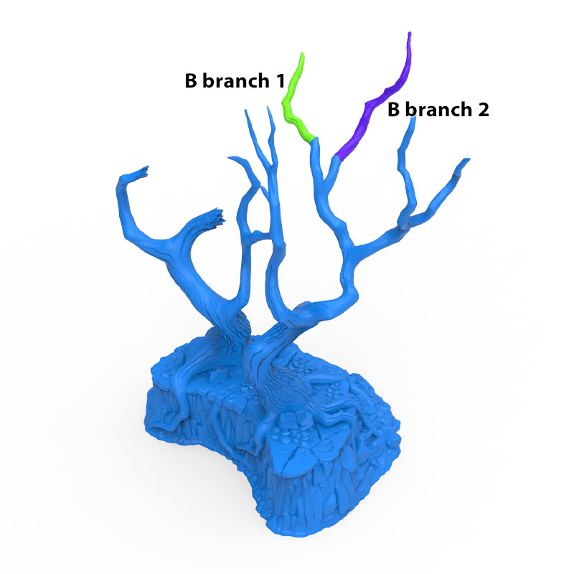Gloomy Gully A*

*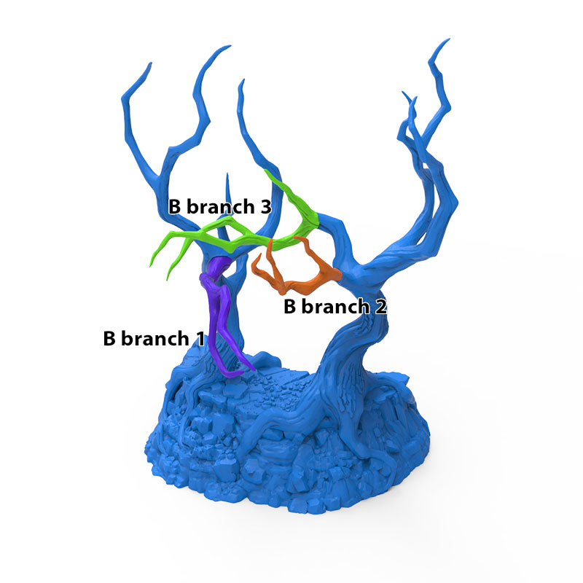Gloomy Gully B*

*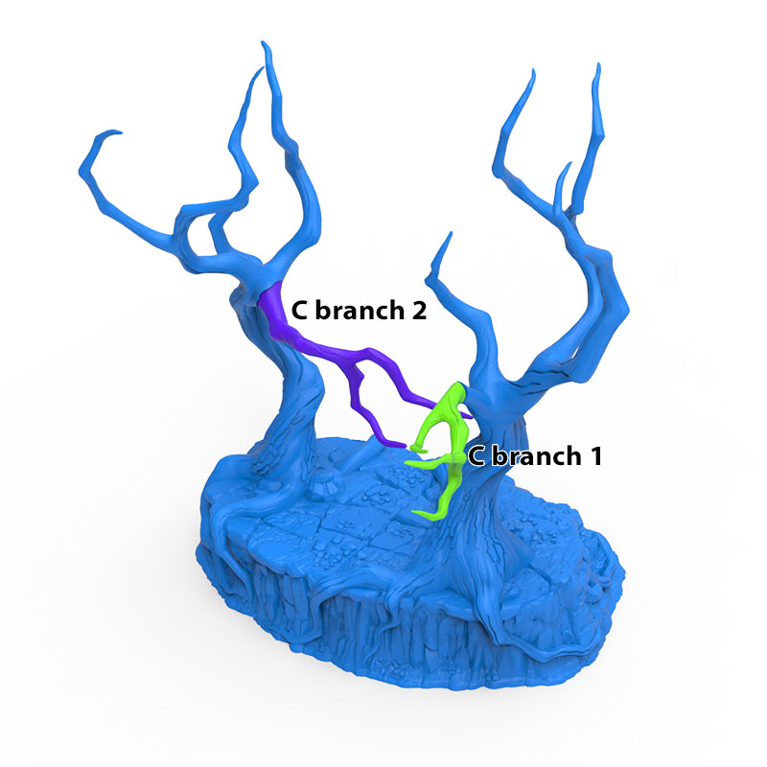Gloomy Gully C*

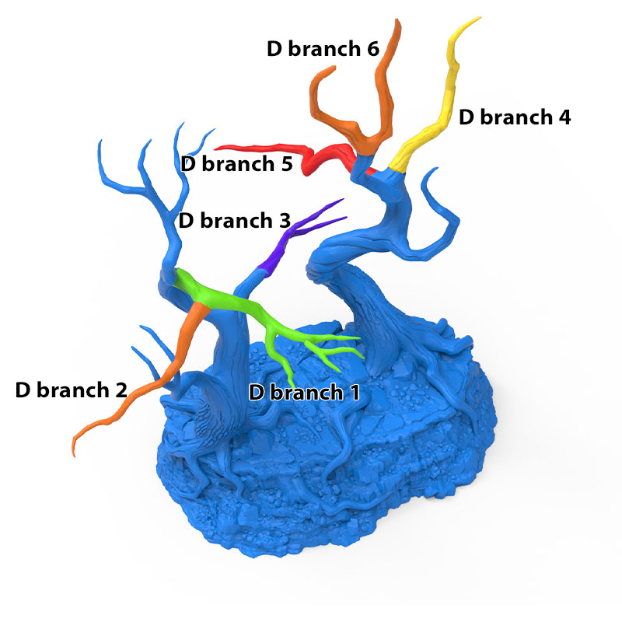

*Gloomy Gully D*